How to change directory in IIS
Open IIS Manager from Administrative Tools and click on the Default Web Site
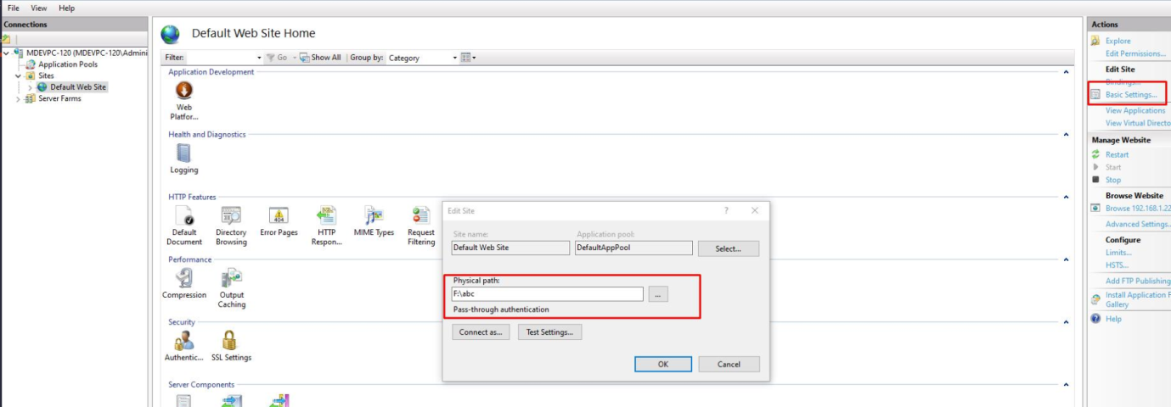
Type in the path to the new log directory that you want to use, or click Browse and navigate to it.
